|  |  |  |  |
| --- | --- | --- | --- |
| SVKM's-IOT, DhuleShri Vile Parle Kelavani Mandal's  **INSTITUTE OF TECHNOLOGY**  **DHULE (M.S.)**  **DEPARMENT OF COMPUTER ENGINEERING** | | | |
| **Subject :** Java Programming Lab(Seminar-1) | | | Remark |
| **Name :**  Ansari Asharul Ameen Naeem Ahmad | | **Roll No. :** 63 |
| **Class:** SY. Comp. Engg. | **Batch : S4** | **Division: A** |
| **Expt. No. :**04 | **Date : 2/9/2024** | | Signature |
| **Title :**  Write Java Programs to demonstrate: Method Calling | | |
|  | | |
|  | | |

**CODE 1 :**

class Ab1{

void show(int x, int y) {

System.out.println(x + " " + y);

}

static void print() {

System.out.println("Static method calling");

}

public static void main(String[] args) {

Ab1 n = new Ab1();

n.show(90, 20);

print();

    }

}

**OUTPUT :**

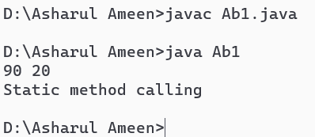

CODE 2 :

import java.util.*;

class abi{

public static void main(String[] args) {

Scanner s = new Scanner(System.in);

System.out.println("Enter a value:");

int d = s.nextInt();

abi x = new abi();

x.area(d);

x.fact(d);

x.r_oe(d);

System.out.println("Enter two numbers to add:");

int num1 = s.nextInt();

int num2 = s.nextInt();

x.add(num1, num2);

}

void area(int s) {

int c = s * s;

System.out.println("Area of Square = " + c);

}

void fact(int n) {

int Fact = 1;

for (int i = 1; i <= n; i++) {

Fact *= i;

}

System.out.println("Factorial of Number = " + Fact);

}

void r_oe(int y) {

if (y % 2 == 0)

System.out.println(y + " is an Even Number");

else

System.out.println(y + " is an Odd Number");

}

void add(int a, int b) {

int sum = a + b;

System.out.println("Sum of " + a + " and " + b + " is " + sum);

}

}

// output

